Kickstarter

Kickstarter is an American public-benefit corporation based in Brooklyn, New York, that maintains a global crowdfunding platform focused on creativity and merchandising. The company's stated mission is to "help bring creative projects to life".

In this analysis I will examine factors that contribute to more successful campaigns and share my conclusions.

Objectives:

1. Given the provided data, what are three conclusions we can draw about Kickstarter campaigns?
2. What are some limitations of this dataset?
3. What are some other possible tables and/or graphs that we could create?



* The most successful campaigns were the ones in the range of 1000 to 4999 a total number of 932 at the 66% success rate.
* A steady decrease of the successful campaigns can be observed on the graph below, from 71% to 19%.
* Percentage of failed projects continues to grow and reached a high 58%.
* Percentage of canceled projects continues to grow and reached a high 23%.
* US category and sub-category for film & video is significantly higher than all “Other countries”. More projects are created and pushed in US than in all other countries based on the dataset provided. 261 succeeded film & video projects versus 39 succeeded film & video projects of other countries.



This study has potential limitations.

* Incomplete data given for the year of 2009 and 2017 ( data given for only 2-3 months of the year).
* No data for 2018 and 2019 years.
* This affects the accuracy of the data at the present moment of this report.

This study is focused on the film & video/television category.

For reviewing this dataset and getting a clearer picture I had to do a Unix conversion using an Excel formula, pivot tables and pivot charts helped me explore and dive deeper into category and subcategory of this data and helped me see the missing data for 2018 and 2019 years.

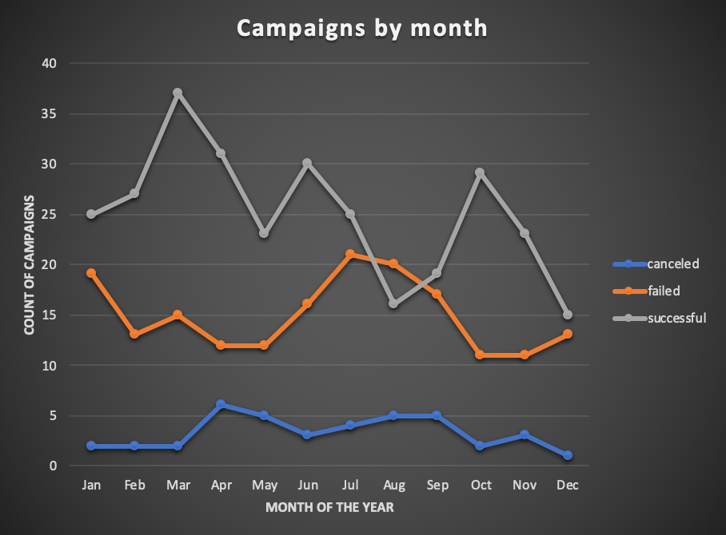

The pivot chart above contains data from 2009 to 2017 for the film & video category. The trend seen is that 300 successful projects predominate, 180 failed projects and only 40 projects were canceled.

In the graph below, the film and video category is examined for the last 3 years ( given in the current dataset, and these are 2015, 2016, 2017). Note the year 2017 contains data for only 2 months, not the entire year.



The most successful months for launching projects in these specific years, turned out to be February, March and April. Spring is a good time for new movies!!!

In total 101 projects were successful, and 100 failed the highest failure trend it is observed in January, June and August.

Conclusion: beginning of the year and middle of the summer are not the good times to launch a movie project.

Data for the past 3 years ( past 3 years not chronological) is pointing towards quite a dualistic view 101 successful projects versus 100 failed ones.

For the future considerations, I think it is critically necessary to study the causes of the failed projects and to eliminate those conditions for future projects, in hope for a better outcome.

All information is information, even if it is least expected or preferred. There is lots of ground to explore and find modalities to improve the technique of launching more successful projects.

I believe that next report would much more accurate with the updated information for the missing years, it would help to create a better understanding of the current trend and help to take more informed business decisions about the best season when to launch a campaign.